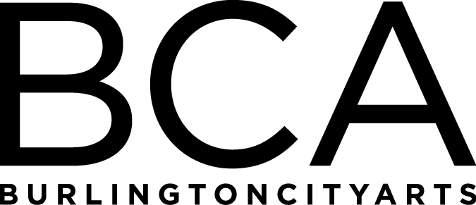

Arts Education Committee Meeting Notes
Tuesday, March 19, 2019, 1:30pm-2:30pm
BCA Center, 2nd floor (LBG room), 135 Church Street
In attendance: Shastina Ann-Wallace, Melinda Johns, Rachel Kahn-Fogel, Jackie Reno, Melissa Steady, Deb Wilkinson, & Kiersten Williams (note taker)
- Welcome Shastina! New education assistant.
- Scholarships review
- BCA has offered scholarships for at least 14 years
- Current hot topic and concern with the city
- How to offer scholarships to those most in need
- Scholarship process is lengthy – Melissa spends 10-25 minutes per application
- BCA never turns someone away
- We spend around $35,000 a year in scholarships
- Streamlining scholarship data collecting
- All departments in city working on this issue

- Questions
- What is appropriate for one family to receive in a year in scholarships?
- How to keep those who register with a scholarship accountable for spot taken?
- Should there be any limits to scholarships offered to individuals outside of Burlington?

- We continue to work on collecting accurate demographic data

FY’19 Meetings:
Tuesday, May 21, 1:30-2:30pm, LOCATION: BCA CENTER
(Board Meeting: 3-5 pm at BCA Center)

Tuesday, June 18, 1:30-2:30pm, LOCATION: TBD
(Board Meeting: 3-5 pm at BCA Center)

Arts Education Committee
The Arts Education Committee includes BCA board members and non-board members and meets 6 times annually. Members of the Arts Education Committee provide experience and expertise in various aspects of life-long learning and connect BCA programs to trends and themes in arts education. The committee evaluates, advises and guides the art education programs, which include education studios, classes, camps and workshops, school artist-in-residence programs at IAA and with Head Start, afterschool programs and Art from the Heart at UVM Medical Center.

