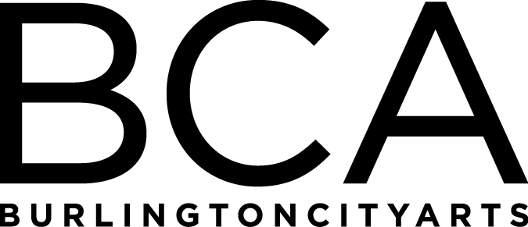

Arts Education Committee Meeting Notes
Tuesday, May 21, 2019, 1:30pm-2:30pm
BCA Center, 2nd floor (LBG room), 135 Church Street
In Attendance: Melinda Johns, Michael Metz, Barbara Perry, Rebecca Schwarz, Melissa Steady, Dana vanderHeyden & Kiersten Williams
- BTV Stats presentation next week at City Hall, focus is on Scholarships
- Strategic plan is shifting from regional to Burlington
- Need better signage and communication concerning 405
- City working together on more projects (Parks, Library)
- We are doing more outreach concerning scholarships
- Total Class Revenue projected to be higher than expected
- Camp approaching, higher enrollment this year
- AFTH has new space in hospital, great news!
- Gallery Education has seen a 25% increase in attendance and a more diverse audience. Collecting data from surveys. Trying to get more attendance to Art in Conversation programs for older adults.
- Sarah Amos Printmaking class at studios ini September
- Mary will return from Medical Leave June 3rd

FY’19 Meetings:
Tuesday, June 18, 1:30-2:30pm, LOCATION: BCA Center, 135 Church Street
(Board Meeting: 3-5 pm at BCA Center)

Arts Education Committee
The Arts Education Committee includes BCA board members and non-board members and meets 6 times annually. Members of the Arts Education Committee provide experience and expertise in various aspects of life-long learning and connect BCA programs to trends and themes in arts education. The committee evaluates, advises and guides the art education programs, which include education studios, classes, camps and workshops, school artist-in-residence programs at IAA and with Head Start, afterschool programs and Art from the Heart at UVM Medical Center.

