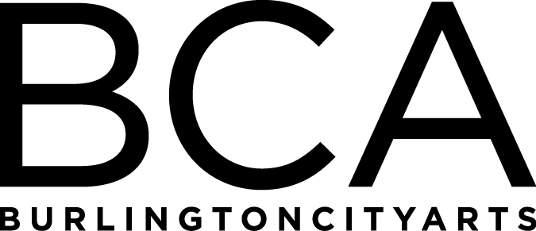

Arts Education Committee Meeting
Tuesday, January 15, 2019, 1:30pm-2:30pm
BCA Center, 2nd floor (LBG room), 135 Church Street
Agenda:
- Winter Spring ‘19 and Camp ’19 review
- Community Programs updates
- Gallery Education updates

FY’19 Meetings:
Tuesday, March 19, 1:30-2:30pm, LOCATION: TBD
(Board Meeting: 3-5 pm at BCA Center)

Tuesday, May 21, 1:30-2:30pm, LOCATION: TBD
(Board Meeting: 3-5 pm at BCA Center)

Tuesday, June 18, 1:30-2:30pm, LOCATION: TBD
(Board Meeting: 3-5 pm at BCA Center)

Arts Education Committee
The Arts Education Committee includes BCA board members and non-board members and meets 6 times annually. Members of the Arts Education Committee provide experience and expertise in various aspects of life-long learning and connect BCA programs to trends and themes in arts education. The committee evaluates, advises and guides the art education programs, which include education studios, classes, camps and workshops, school artist-in-residence programs at IAA and with Head Start, afterschool programs and Art from the Heart at UVM Medical Center.

