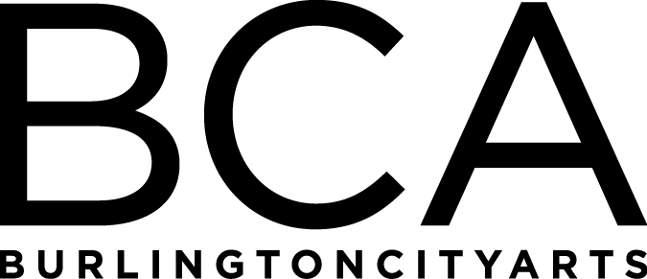

Arts Education Committee Meeting
Tuesday, November 20, 2018, 1:15pm-2pm
BCA Center, 135 Church Street, LBG, 2nd floor
Agenda:
- Fall ‘18 updates and comparisons to last year
- Community Programs and Gallery Education updates

FY’19 Meetings:
Tuesday, January 15, 1:30-2:30pm, BCA Studios, 405 Pine Street
(Board Meeting: 3-5 pm at BCA Center)

Tuesday, March 19, 1:30-2:30pm, BCA Studios, 405 Pine Street
(Board Meeting: 3-5 pm at BCA Center)

Tuesday, May 21, 1:30-2:30pm, BCA Studios, 405 Pine Street
(Board Meeting: 3-5 pm at BCA Center)

Tuesday, June 18, 1:30-2:30pm, LOCATION: TBD
(Board Meeting: 3-5 pm at BCA Center)

Arts Education Committee
The Arts Education Committee includes BCA board members and non-board members and meets 6 times annually. Members of the Arts Education Committee provide experience and expertise in various aspects of life-long learning and connect BCA programs to trends and themes in arts education. The committee evaluates, advises and guides the art education programs, which include education studios, classes, camps and workshops, school artist-in-residence programs at IAA and with Head Start, afterschool programs and Art from the Heart at UVM Medical Center.

