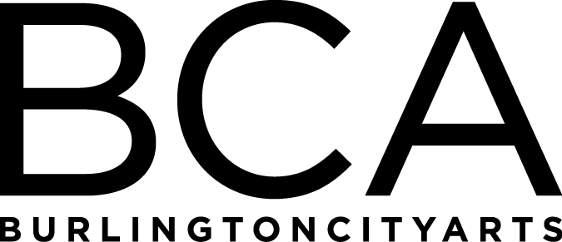

Arts Education Committee Meeting Notes
Tuesday, January 15, 2019, 1:30pm-2:30pm
BCA Center, 2nd floor (LBG room), 135 Church Street
In Attendance: Alissa Faber, Renee Greenlee, Melinda Johns, Rachel Kahn-Fogel, Jackie Reno, Lori Rowe, Rebecca Schwarz, Melissa Steady, Dana vanderHeyden, & Kiersten Williams
- Staff Updates – Mary Zompetti out on leave, Kate McKernan leaving administrative role. Will be hiring new Education Assistant, Camp Coordinator, and 2 Camp Assistants
- Winter Spring ‘19 and Camp ’19 review – we are running more Winter/Spring classes than ever this year and are on track to exceed income expectations. We are offering 68 camps this summer, 3 more than last year
- Drop-Ins have all changed to ticketed programs to improve customer service and be able to offer scholarships. Suggested made to make scholarship awardees clear that scholarship for Friday Clay Program is for class and not extra firing fee. Although, staff will be informed to be more flexible on if needed.
- Education Programming costs twice as much as we can bring in
- Access to 405 is a balance between studio members and studio classes
- Clay Studio continues to have huge waitlist and over 75 users, all other studios have increased their membership as well – will never be at the same level as clay
- Community Programs updates – More marketing for community programs was suggested. Children’s Art Exhibit coming up. Art From the Heart is still looking for more contributions from the hospital. An ask was made this fall and BCA was told no to more money.
- Gallery Education updates- Melinda is trying new public programs and is increasing tour numbers
- Evaluation Forms and Scholarship Forms were reviewed.
- Next meeting will be at the BCA Center per request of Board Members. Melissa will bring Evaluations results to the next meeting.

FY’19 Meetings:
Tuesday, March 19, 1:30-2:30pm, LOCATION: BCA Center 2nd Floor
(Board Meeting: 3-5 pm at BCA Center)

Tuesday, May 21, 1:30-2:30pm, LOCATION: TBD
(Board Meeting: 3-5 pm at BCA Center)

Tuesday, June 18, 1:30-2:30pm, LOCATION: TBD
(Board Meeting: 3-5 pm at BCA Center)

Arts Education Committee
The Arts Education Committee includes BCA board members and non-board members and meets 6 times annually. Members of the Arts Education Committee provide experience and expertise in various aspects of life-long learning and connect BCA programs to trends and themes in arts education. The committee evaluates, advises and guides the art education programs, which include education studios, classes, camps and workshops, school artist-in-residence programs at IAA and with Head Start, afterschool programs and Art from the Heart at UVM Medical Center.

