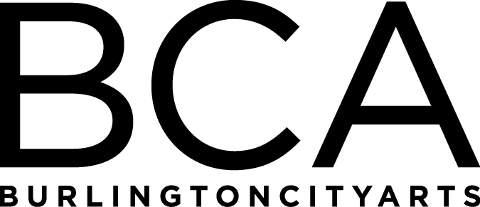

Arts Education Committee meeting
Tuesday, May 15, 2018, 1:30-2:30pm
BCA Studios, 405 Pine Street
In attendance: Michael Metz, Barbara Perry, Kiersten Williams, Mary Zompetti, Melissa Steady, Rebecca Schwarz, Dana vanderHeyden and Rachel Kahn-Fogel
Notes:
- Winter/Spring Classes, Open Studio and Summer Camp update – projecting to hit $195,000 goal, working Drop-In class changes and strategies, Open Studio updates, Photo renters have tripled in FY’18, we are 40 campers higher than last year
- Community Programs update – AFTH coordinator job hours to increase thanks to support from UVMMC, fundraiser coming up, IAA Residencies updates, Early Arts
- Discussion of the strengths and weaknesses of our offerings and future improvements-staff needs help with physical upkeep of the building
- Committee value, activity and help – Education Staff will work on creating wish lists of equipment and supplies needed by the studios and will send to Michael Metz

Next Meeting:
Tuesday, June 19, 2018, 1:30-2:30pm at the BCA Center, 135 Church Street (2nd floor)

Arts Education Committee
The Arts Education Committee includes BCA board members and non-board members and meets 6 times annually. Members of the Arts Education Committee provide experience and expertise in various aspects of life-long learning and connect BCA programs to trends and themes in arts education. The committee evaluates, advises and guides the art education programs, which include education studios, classes, camps and workshops, school artist-in-residence programs at IAA and with Head Start, afterschool programs and Art from the Heart at UVM Medical Center.

