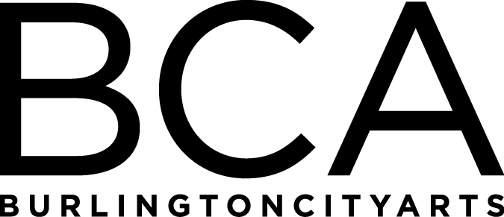

Arts Education Committee Meeting Notes
Tuesday, June 19, 2018, 1:30-2:30pm
BCA Center, 2nd floor, 135 Church Street
In Attendance: Alissa Faber, Michael Metz, Lori Rowe, Rebecca Schwarz, Melissa Steady, Dana vanderHeyden & Kiersten Williams
Agenda:
- BCA Education one page overview – review development information on handout
- Summer Camp update
  - 2018- 554 campers enrolled (524 half day, 30 full-day- 40 camps full out of 69 (not including Aftercare)- 58% full
  - 2017- 494 enrolled around this date (478 half day, 31 full-day- 35 camps full out of 61 (not including Aftercare)- 57% full
  - 2016- 593 enrolled around this date (556 half-day, 37 full-day- 32 camps full out of 74 (not including Aftercare)- 43% full
  - Soundproofing going up between classrooms
  - Filling less camps with more kids

- Discussion of the strengths and weaknesses of our offerings and future improvements
  - Class income hitting above budget
  - Studio Education & Gallery Education connections are needed

- Committee value, activity and help
  - Committee was given wish list of supplies needed at the studios

Arts Education Committee
The Arts Education Committee includes BCA board members and non-board members and meets 6 times annually. Members of the Arts Education Committee provide experience and expertise in various aspects of life-long learning and connect BCA programs to trends and themes in arts education. The committee evaluates, advises and guides the art education programs, which include education studios, classes, camps and workshops, school artist-in-residence programs at IAA and with Head Start, afterschool programs and Art from the Heart at UVM Medical Center.

